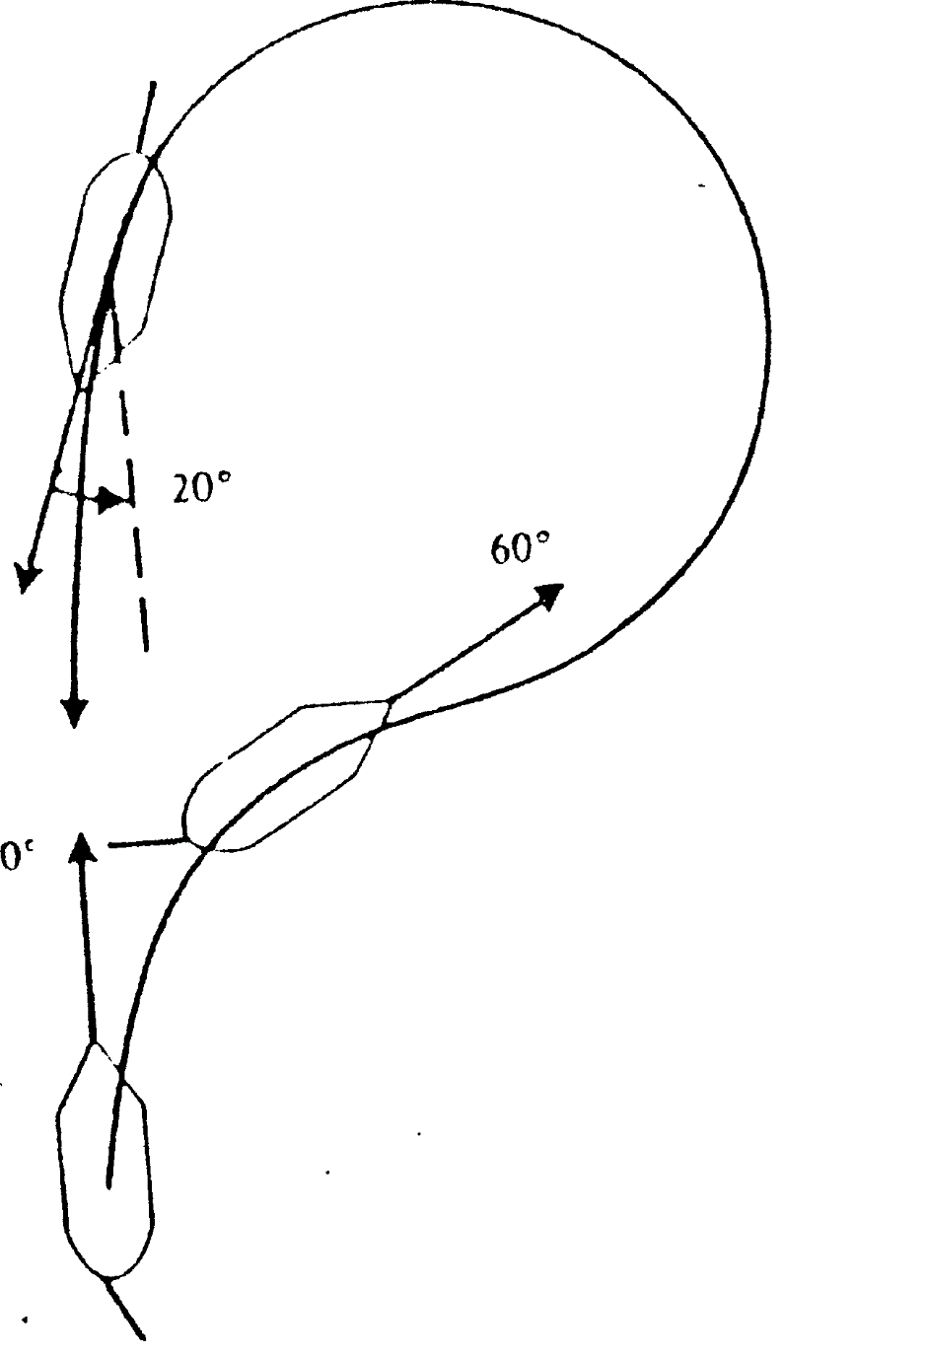
MAN OVERBOARD
WILLIAMSON TURN

1 | Put the helm HARD the same side as Man overboard
2 | Release lifebuoy with light and smoke signal
3 | Mark MOB on ECDIS or GPS
4 | Sound three prolonged blast of the ship whistle
5 | Post watch keeper permanently looking at the man overboard
6 | Commence a recovery manoeuvre “Williamson turn”
7 | Inform engine room
8 | Muster rescue boat, prepare for launching
9 | Note ship’s position, wind, speed, time etc.
10 | Hoist signal flag “OSCAR”
11 | Warn a close vessels by VHF about incident

